- Purpose
  - The purpose of this document is to describe the procedure for installing options on the final assembly of the Genesys Mid-Sized Scrubber.
- Scope
  - This SOP applies to all equipment assembly team members. The process applies to all machine ID’s:
- Responsibilities
  - The operations manager/supervisor is responsible for enforcing this SOP.
- Materials
  - The proper materials needed for this process are listed on the machine work order.
- Definitions

- Procedure
  - Wet Battery Protection
    - Install a watering kit (E29704). Take each of the 4 probe assemblies and install them into a battery. Place the probe with the wire into the battery shown. Once in place, connect the 4 probe assemblies with the water line. Press each connection until it snaps into place.
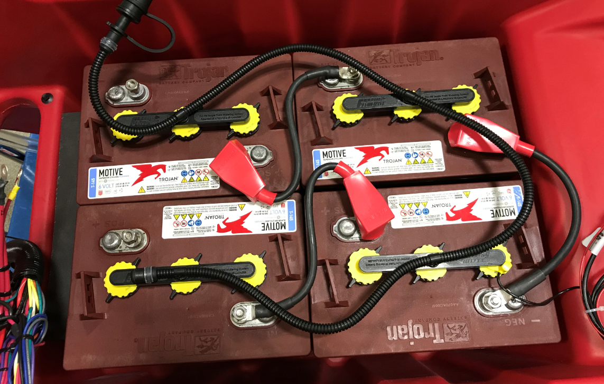
Probe w/ wire
Front of
Machine
Operator
Side

    - Take an indicator LED (E29344). Cut out the hole in the panel decal on the electrical panel. It is located above the Fortify logo. Install the LED using the supplied washer and nut. Ensure that it is tight.
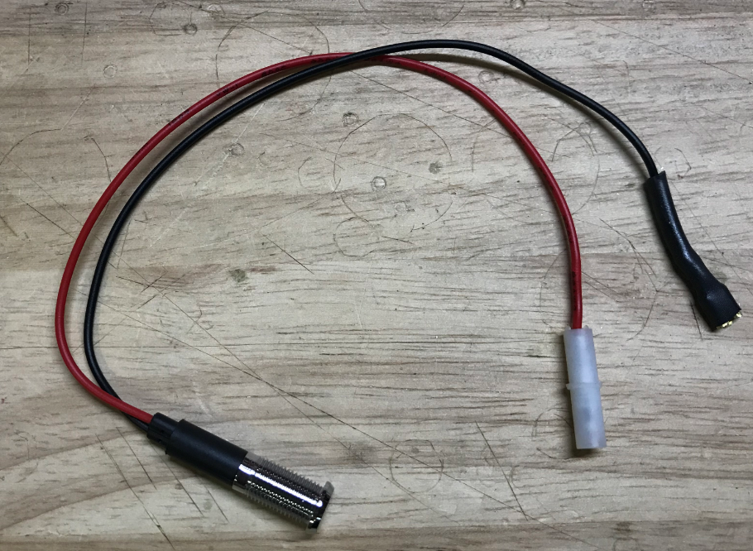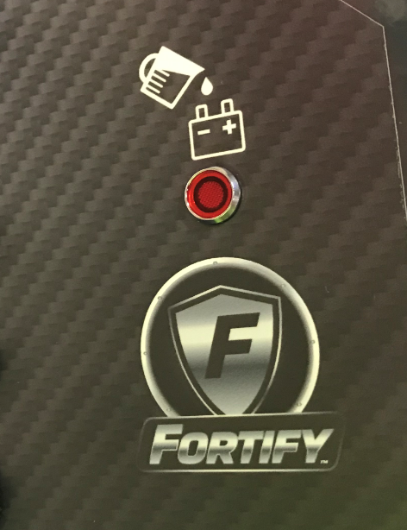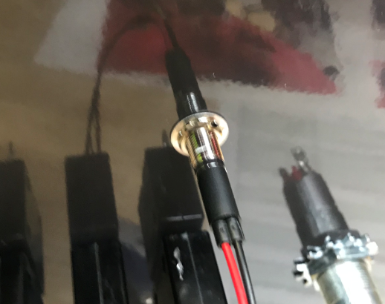
    - Locate the board on the electrical panel. Remove the jumper shown.
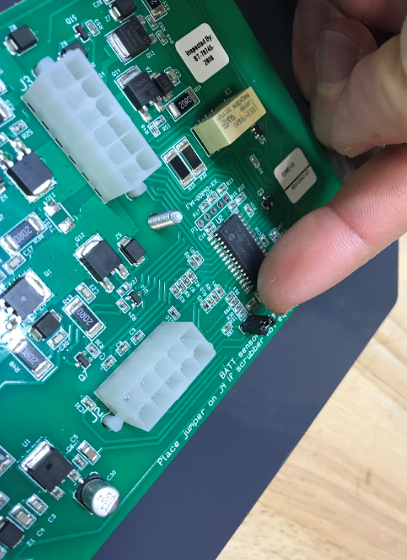
    - Feed the two wires from the WBP unit through the battery compartment and into the panel area. Connect them to the appropriate connectors on the main harness.

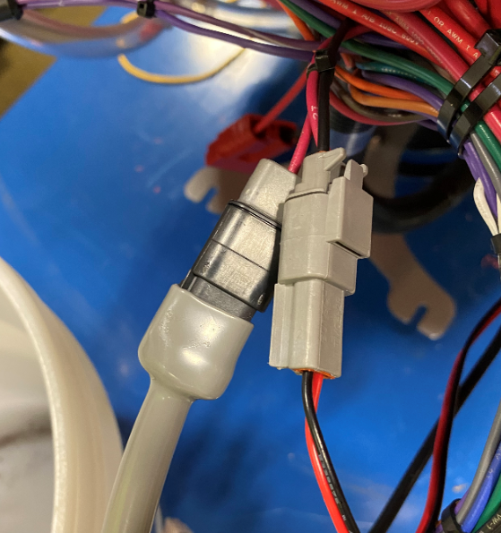
    - Connect the Fortify LED on the back panel to the appropriate connectors on the main harness. Use 2 zip ties (E83523) to clean up the wiring.

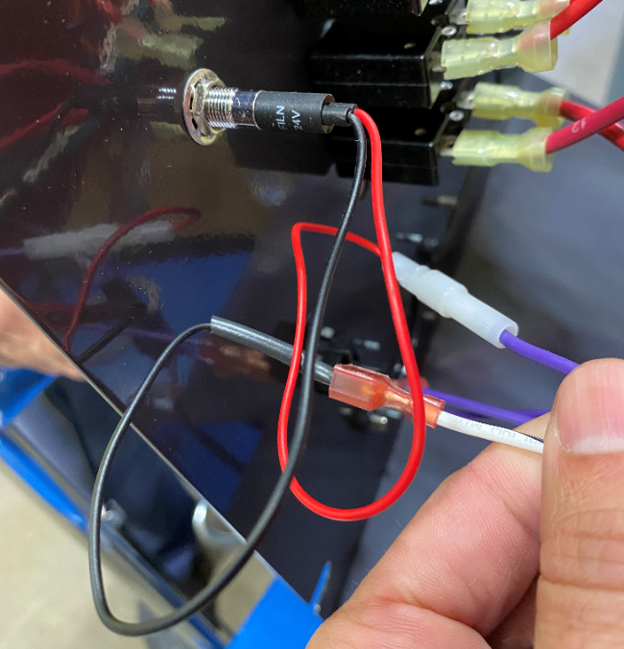
9
47

- References (optional section as needed)

- Training Guide

Functional Training Groups Requiring Training
Equipment Assembly Group

- SOP Change Control

Date of Change | Reason for Change
Rev 01 | This is the first version of the S.O.P. hence there are no revisions to this document.
Rev 02 - 5/14/2025 | Removed Bluetooth BDI Instructions, Timer Instructions, and Armor Instructions

Approvals

Submitter/Author Approval:__________________________________ Date:______________________

Management Approval:______________________________________ Date:______________________

QAU Approval:_____________________________________________ Date:______________________

